**PRESS RELEASE**





****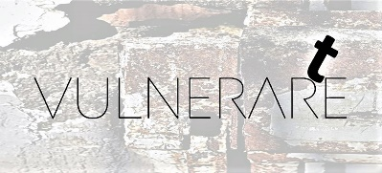

**IAMVULNERABLE**

***failure* is an achievement, art is loving *error***   
recognized among the *'Good Cultural Practices of the Lazio Region'*among the official initiatives of the *‘Twentieth Edition of the Contemporary Day’*

**a project curated by Sergio Mario Illuminato**

**From October 3 to November 29, 2024**

**Italian Cultural Institute in Paris**

**Hôtel de Galliffet - 50, rue de Varenne -75007 Paris**

**Inauguration: Thursday, October 3, 2024 - 6:00 PM**

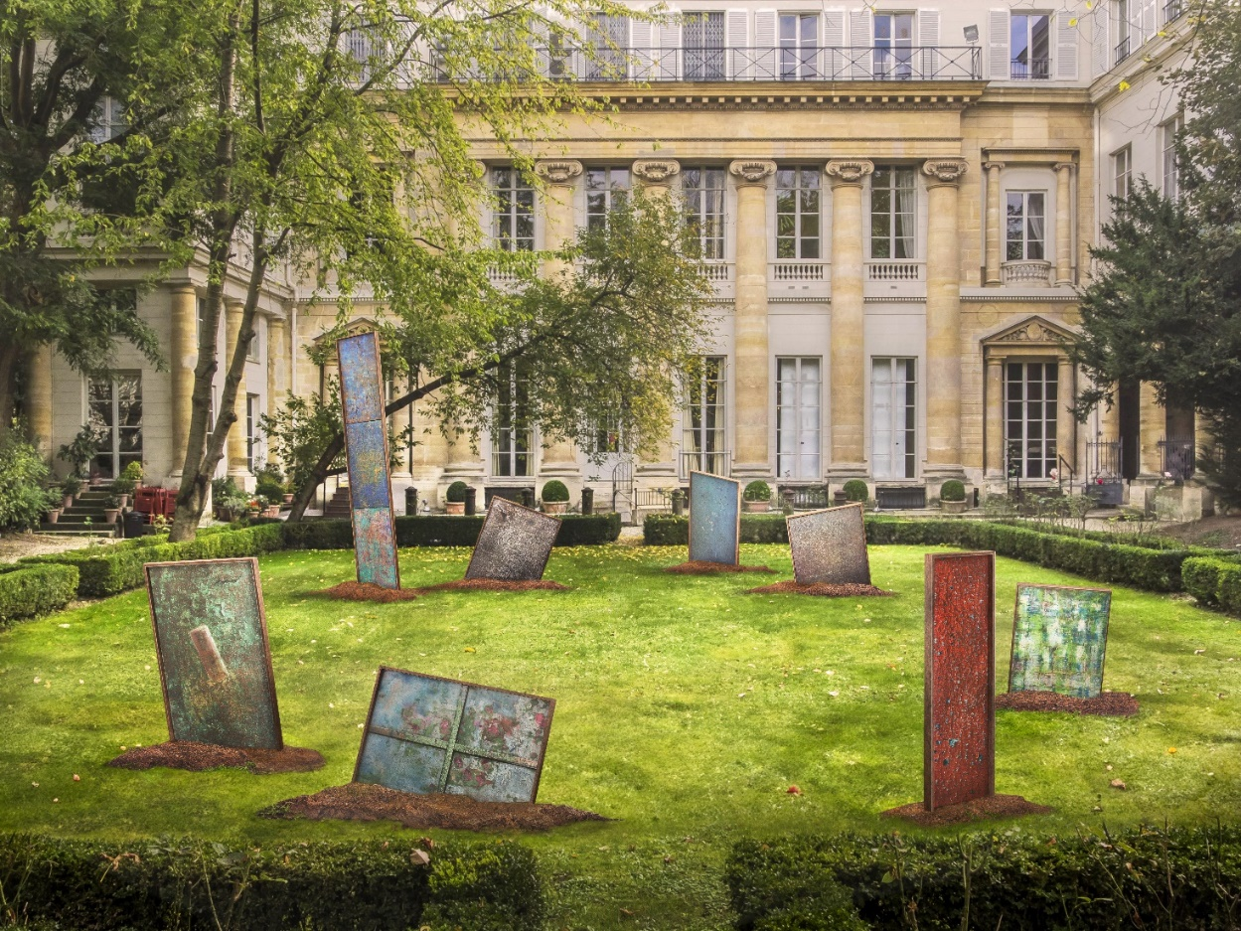

From **October 3 to November 29, 2024**, the **Italian Cultural Institute in Paris** will present **IAMVULNERABLE**, *Failure is an Achievement - Art is Loving Error*, a transdisciplinary performative practice curated by **Sergio Mario Illuminato**, ranging from the latest artistic experimentation to the emerging creativity of schools and european academies. The **inauguration** of the initiative will take place on Thursday, **October 3 at 6:00 PM** at the Institute's headquarters in Paris, Hôtel de Galliffet, at 50 rue de Varenne.

IAMVULNERABLE is a journey through art and vulnerability carried out in several chapters. Started through an artist residency at the former Pontifical Prison of Velletri last January, the project continues in Paris and then continues next December in Rome, in the spaces of the Historical Museum of Villa Altieri. In the prestigious French setting, a group of artists of 'living matter' will compose an expressive mosaic, using transdisciplinary formats and languages to explore the theme of human vulnerability as a tool for social and civil cohesion.

Painting-sculpture and photography-cinema will dialogue with reality, inviting the visitor to look beyond the nightmares of the twenty-first century and to seek deeper solicitations to illuminate alternative futures. In the garden designed by architect Luigi Moretti, the *Communicating Artistic Organisms*, fragile and informal in their essence as if fallen from the sky, will evoke the 'ruins' of contemporary everyday life, while natural light will highlight photographic shots of *Rare Earths*, immersed among decaying cells and inscriptions etched by the inmates. Music and sound, crucial elements of the installation, will accompany the audience on a complete sensory experience, inspired by the theories of Maurice Merleau-Ponty.

The inaugural event will be opened by the Director of the Institute, **Antonio Calbi**, and the curator Sergio Mario Illuminato, with the participation of H.E. Ambassador **Liborio Stellino**, Permanent Representative of Italy to UNESCO, of **Alessandra Maria Porfidia**, Director of the Sculpture School at the Academy of Fine Arts in Rome. To follow, there will be a private preview screening of the short film *Vulnerare*, currently in competition at major international festivals, introduced by **Giulio Casini,** professor at the Libera Università del Cinema in Rome. Finally, the participants will have the opportunity to ‘dive’ in the *Communicating Artistic Organisms* installed in the Institute's garden, accompanied by a tasting of the Sicilian wine *Pietradolce*, originating from the lands of Etna.

Among the installations will be *Jonchets, or Shanghai*, a collective work by young artists from the Academy of Fine Arts in Rome, which invites us not to give in to contemporary social and environmental crises. It is up to all of us - they declare - *to try to pull out, one by one, as many fears and vulnerabilities as possible from the complexity of everyday life, seeking a momentum towards contact and emotion.*

**Participating artists: Sergio Mario Illuminato** (painting-sculpture), **Rosa Maria Zito** (scenography and photography), **Roberto Biagiotti** (cinema), **Lucia Bendia** (theater), **Patrizia Cavola e Ivan Truol** (choreography), **Camilla Perugini e Nicholas Baffoni** (dance), **Andrea Moscianese** (music), **Davide Palmiotto** (sound design), **Roberta Melasecca** (publishing), **Gino Potini** (lighting design); the young artists of the Sculpture School of the Academy of Fine Arts in Rome directed by **Alessandra Maria Porfidia**: **Vittoria Andreacchi, Rossella Antezza, Maria Vittoria Rocchi, Violetta Totaro;** the students from the Piaget-Diaz State Higher Education Institute in Rome coordinated by **Serena Santilli**.

*Culture is an opportunity for development and growth, and sometimes even a way for fighting against injustices. The first step through is to accept our own fragilities. In a world that constantly asks for perfection, we choose to exalt vulnerability, the beauty of the simple and pure gesture.* (**Antonio Calbi**, Director of the Italian Cultural Institute of Paris)

*The artistic devices presented in this project* - says **Sergio Mario Illuminato**- *are conceived as 'time capsules' of beauty and perfection that have become ephemeral; cast by Prometheus, they are meant to serve once again as catalysts to regenerate deeper spaces, similar to underground fires, which lead back to the depths of humanity and, from there, to the infinity of the sky.*

*The central theme around which the en-re cultural project revolves is vulnerability, -* says **Federico Mollicone**, President of the Culture Commission of the Chambre des Députés *- which can be aesthe-cally and transversally expressed in many ways. For example, the socially fragile individual is vulnerable, as is the degraded neighborhood that is not revitalized or the family leU behind in its distress. Art has the mythopoe-c power to transform this vulnerability – degrada-on, suffering, and loneliness – into beauty. As curator Illuminato writes, “art is not a luxury, but a vital necessity.”*

For **Marco Maria Cerbo**, Head of the Coordination Unit of the Italian Cultural Institutes at the Ministry of Foreign Affairs and International Cooperation, *IOSONOVULNERABILE embodies one of the principles that inspires our country's cultural diplomacy: that of inclusion, which is expressed through a successful exercise of collaboration between public and non-profit institutions.*

*The now three-year collaboration with IAMVULNERABLE* *strengthens our ongoing commitment to building models of human and collective development that reflect the complexity and beauty of our existence.* ***Pierluigi Sanna****, Deputy Mayor of the Metropolitan City of Rome Capital.*

For **Miguel Gotor**, Councilor for Culture of Rome Capital, *Rome has a rich cultural heritage and a history that makes it the perfect place to embrace new artistic avant-gardes. With 'iosonovulnerabile' and its curator Sergio Mario Illuminato, we hope to open to new creative dialogues, inspiring a deep reconsideration not only of art but also of human vulnerability and historical memory. I believe this project can foster the emergence of new experiences and reflections, strengthening Rome's role as a cultural capital open to innovation.*

IAMVULNERABLE, inspired by the book *Corpus et Vulnus* published by Sergio Mario Illuminato, is a project of the VulnerarTe APS Movement, recognized among the *'Good Cultural Practices of the Lazio Region'*.

Under the Auspices of the Presidency of the VII Commission (Culture, Science and Education) of the **Chamber of Deputies**. Under the Patronage of the **European Parliament**, Italian **Ministry of Foreign Affairs**, **Lazio Region**, **Metropolitan City of Rome Capital,** **Department of Culture of Rome Capital.**

IAMVULNERABLE is among the official initiatives of the twentieth edition of the Contemporary Day promoted by AMACI – **Association of Italian Contemporary Art Museums** and realized with the support of the General Directorate for Contemporary Creativity of the **Ministry of Culture** and the collaboration of the General Directorate for Public and Cultural Diplomacy of the **Ministry of Foreign Affairs and International Cooperation.**

**UNDER THE AUSPICES OF THE PRESIDENCY OF THE VII COMMISSION   
(CULTURE, SCIENCE AND EDUCATION) OF THE CHAMBER OF DEPUTIES**

**UNDER THE PATRONAGE / RECOGNITION OF**



** MEDIA PARTNER**  **PROJECT MAGAZINE TECHNICAL PARTNER**

**IN COLLABORATION WITH**

Academy of Fine Arts, Piaget Diaz State Higher Education Institute, Blowart Cultural Association,   
Teatro Valmisa, Cooperative Society, Botanical Garden of the University of Rome 'La Sapienza', Rossini Lab

**For further information:**

Italian Cultural Institute in Paris**: Grazia Labagnara, Stefano Questioli** - Cultural attachés - [iicparigi@esteri.it](mailto:iicparigi@esteri.it)

Movimento VulnerarTe APS: **Maria Grazia Abete** - Institutional Relations - [iosonovulnerabile@gmail.com](mailto:iosonovulnerabile@gmail.com)

**Reference sites and social networks:**

**[www.iosonovulnerabile.it/practive-performative/2024-2](https://www.iosonovulnerabile.it/practive-performative/2024-2)/**

[www.instagram.com/iosonovulnerabile/](https://www.instagram.com/iosonovulnerabile/) [www.facebook.com/iosonovulnerabile/](http://www.facebook.com/iosonovulnerabile/)

<https://iicparigi.esteri.it/it/> [www.instagram.com/iicparigi/](http://www.instagram.com/iicparigi/) [www.facebook.com/iicparigi](http://www.facebook.com/iicparigi)

**Contacts for Press and Promotion:**

Italian Cultural Institute in Paris: **Sara Garbagnoli**, **Francesco Boscolo Lisetto** - iicparigi@esteri.it

VulnerarTe APS Movement: **Elisabetta Castiglioni** - [info@elisabettacastiglioni.it](mailto:info@elisabettacastiglioni.it) +39 328 4112014

**CURATOR'S NOTES**

***What makes 'I Am Vulnerable' so different, so interesting?***

We find ourselves in a place of great history and beauty, the Hôtel de Galliffet, to celebrate a performative practice that is not just an art exhibition but a cry of vulnerability and courage. IAMVULNERABLE, *Failure is an Achievement - Art is Loving Error* is not just a title but a **call to action**, a challenge to see beyond our fears and failures, and to find in them the strength to build a better future.

At a time when art often seems enshrined in niches of perfection and consumption, this project invites us to rediscover our most authentic humanity. The artistic devices are not mere aesthetic creations but represent **fragments of our existence**, incarnations of our fragility. Each piece exhibited is a dialogue between the artist and the world, a process of dematerialization that reminds us of the urgent need to care for our environment, our communities, and, above all, ourselves.

The theme of vulnerability is more relevant than ever. We live in an age of incessant conflicts, climate crises, and existential threats. IAMVULNERABLE challenges us to confront these realities and find the courage to **turn our vulnerability into a source of strength and connection**.

The installations in the garden designed by Luigi Moretti are **powerful symbols of the 'ruins'** of our everyday lives, but also of hope and rebirth. The ***Communicating Artistic Organisms*** are destined to degrade and eventually disappear under the influence of natural elements, an extreme sacrifice that the artists have chosen to make. The process of deterioration reflects the transience of life and the inevitability of change, embodying a philosophy that celebrates impermanence and the beauty of the ephemeral.

**The voluntary degradation of the exhibited artistic devices** is not just an act of surrender to the natural elements, but a powerful statement of philosophical and artistic values. By rejecting the idea of eternity and perfection, IAMVULNERABLE invites us to recognize the preciousness of the present moment and the need to live in harmony with our environment. Their artistic sacrifice is a call to our collective responsibility to protect and preserve the world around us.

**Art is not a luxury but a vital necessity**. It is a way for exploring and accepting our vulnerability, for better understanding our mistakes, and using them as springboards for personal and collective growth. Art, in all its forms, is a tool for social cohesion, a catalyst for change.

The artists, curator, and organizers thank the spectators-actors for making this extraordinary event possible and for being part of this journey.

**Sergio Mario Illuminato**