PRESS RELEASE

VULNERARE
Debut Film by Sergio Mario Illuminato
From Prison to Art: an Exploration of the Existential Drama of Human Vulnerability

World press preview: Thursday, October 3, 2024, 6:00 PM, at the Italian Cultural Institute in Paris

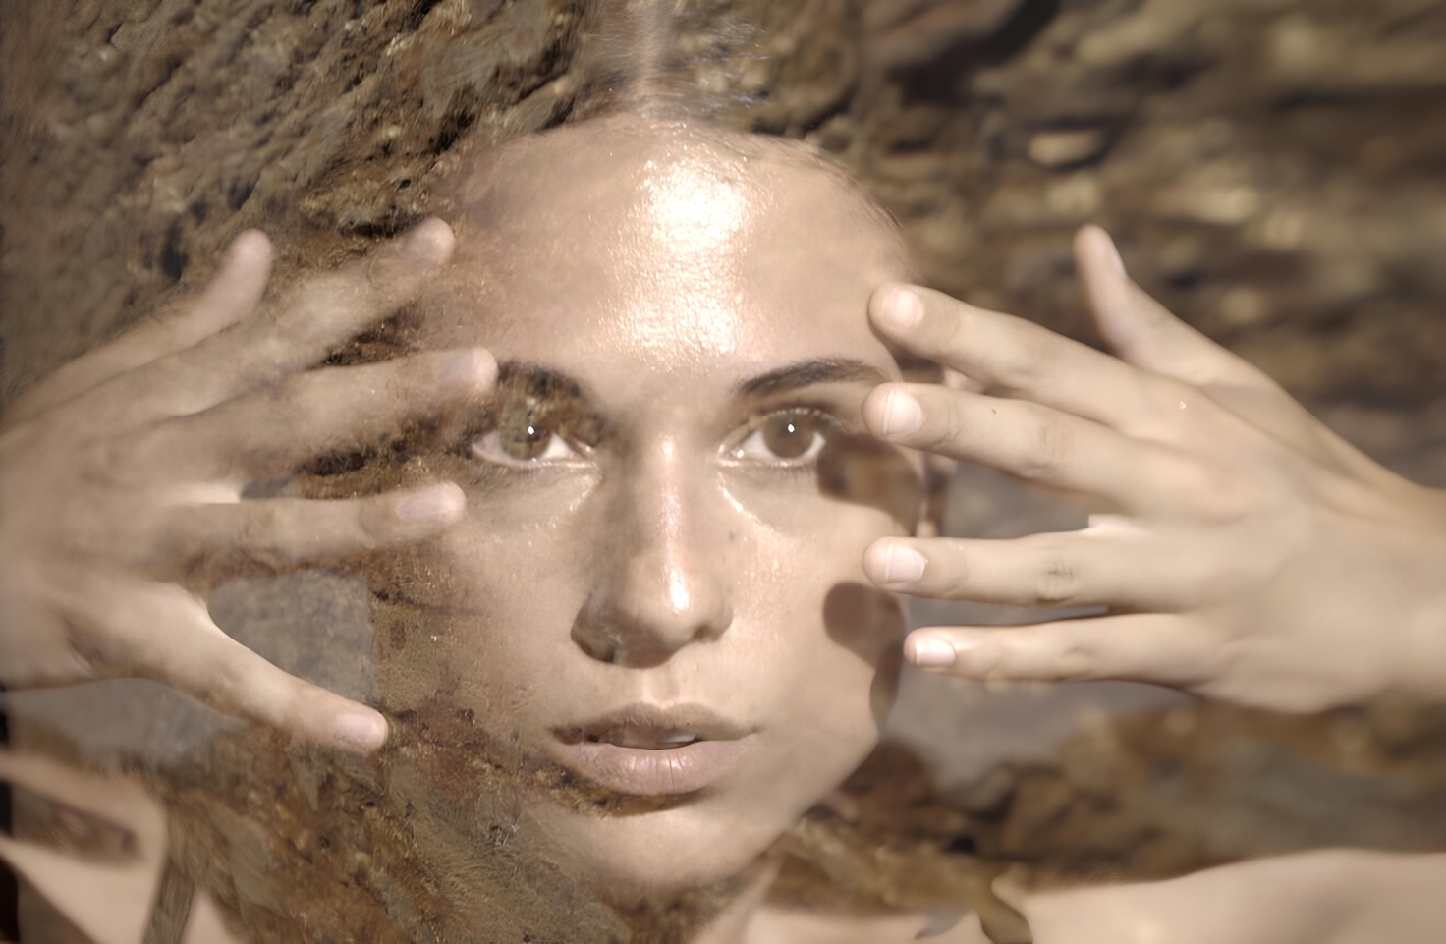

On October 3, 2024, at 6:00 PM, the Italian Cultural Institute of Paris will host the world premiere of VULNERARE—the debut short film by Sergio Mario Illuminato—which explores human vulnerability through artistic creativity. This screening is part of the artistic project ‘IAMVULNERABLE, failure is an achievement - art is loving error,' a transdisciplinary performative practice embracing contemporary artistic experimentation and emerging creativity from European schools and academies.
The film was shot in the fascinating setting of the former Pontifical Prison of Velletri, a historic site built after the death of Giuseppe Garibaldi, an honorary citizen and national hero. Abandoned for over 30 years and slated for demolition, the prison was chosen by Illuminato as the backdrop to revive the hidden vulnerability within its ancient walls through a group of contemporary artists—painters, photographers, filmmakers, dancers, and musicians. This collective, a kind of 'Urbex Squad,' explored and reanimated the dilapidated spaces, bringing to light emotions and memories through the 'Communicating Artistic Organisms.'
"In response to the current dramatic situation," Illuminato states, "I felt the urgency to react creatively, escaping the anesthetic spaces that confine art to the margins of everyday life. I sought to 'bring the world into being,' as Alighiero Boetti used to say. VULNERARE is an attempt to rehabilitate the 'contemporary cathedrals of vulnerability,' forgotten spaces and memories. In the heart of the former Pontifical Prison, where eroded walls narrate a past of isolation, these same walls become a canvas to explore human vulnerability, transforming oblivion into art and dialogue for future generations."
VULNERARE intertwines art and architecture in a fascinating blend of drama and creativity, exploring the contrasts between the painful prison past and the vitality of artistic expression. The narrative focuses on the transformation of a place of pain and solitude into a space of artistic revelation, where the 19th-century context becomes a symbol of change.
Throughout the film, Illuminato layers conflicts and revelations, expertly blending elements of mystery, introspection, and art. The abandoned and time-worn prison cells become a creative stage where vulnerability emerges as one of the most powerful forms of human expression.
The work stands out for its intense synergy of cinematography, color, music, and sound, generating a visual and psychological impact where reality and abstraction merge. The climax of the short film underscores the crucial role of art as a means to understand life and emotions, offering deep reflection on the connection between vulnerability and creativity.
The subject, direction, and editing of VULNERARE are by Sergio Mario Illuminato, with cinematography and filming by Federico Marchi and Roberto Biagiotti, location and art direction by Rosa Maria Zito, original music by Andrea Moscianese, sound design by Davide Palmiotto, choreography by Patrizia Cavola and Ivan Truol, and featuring Camilla Perugini and Nicholas Baffoni. Post-production was handled by Pyramid Factory, with conforming by Elena Becchetti and colorist Alessandro Ammendola.
The central theme of VULNERARE was previously anticipated through a performative practice conducted from September 30, 2023, to January 30, 2024, in the same former Pontifical Prison of Velletri before its final transformation. This practice reinforced the film's key themes, creating a direct link between the past and the present.
Following the screening of the short film, introduced by Giulio Casini, professor at the Libera Università del Cinema in Rome, there will be an "immersive" visit to the 'Communicating Artistic Organisms', installed in the garden of the Italian Cultural Institute, and a tasting of Pietradolce wine from the volcanic soils of Mount Etna, Sicily.
The Institute is located in the historic Hôtel de Galliffet, 50 rue de Varenne, Paris.
For further information and event participation requests, please contact:
Italian Cultural Institute in Paris: Sara Garbagnoli, Francesco Boscolo Lisetto – iicparigi@esteri.it
Movimento VulnerarTe APS: Elisabetta Castiglioni – info@elisabettacastiglioni.it Tel. +39 328 4112014
'IOSONOVULNERABILE' is carried out under the patronage of the European Parliament, the Ministry of Foreign Affairs, the Lazio Region, the Metropolitan City of Rome, and the Department of Culture of Rome. The project is promoted by the Movimento VulnerarTe APS and is part of the 20th edition of the Giornata del Contemporaneo, organized by AMACI, with the support of the Directorate-General for Contemporary Creativity of the Ministry of Culture, in collaboration with the Ministry of Foreign Affairs.
Official website: https://www.iosonovulnerabile.it/short-film/eng/
Press Kit: iosonovulnerabile.it/press-kit

